Narrogin Senior High School
Biological Sciences
Task 6

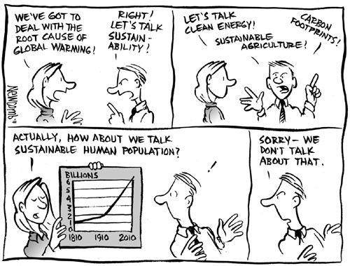

Total: 60 Marks

Multichoice 19 Marks

1. The term population can best be defined as

(a) organisms sharing the same habitat, at a particular time
(b) members of a particular species living in a particular place, at a particular time
(c) all the organisms that occur in a given area, at a particular time
(d) individuals with the same genetic makeup living as a family group, at a particular time

2. From a study of a population that contained about 10 000 individuals the following statistics were obtained.
In one year there were 2000 births,70 emigrants,1300 deaths and 140 immigrants. The rate of change of the population would be

(a) 77
(b) 770
(c) 50
(d) 15

3. In an area of 1500 square metres the rabbit population was 800. Two months later in the same area the population was reduced to one fifth. The population density changed from

(a) 5 per square metre to 2 per square metre
(b) 1.8 per square meter to 7.5 per square metre
(c) 0.5 per square metre to 0.1 per square metre
(d) 0.5 per square metre to 1 per square metre

4. The crown of thorns starfish is a poisonous animal found in tropical waters especially on coral reefs such as the Great Barrier Reef. During the last 30 years there has been a sharp increase in its numbers.

Which of the following factors would NOT have contributed to the increase in the population size of the crown of thorns, on any particular reef?

(a) increased immigration
(b) increased emigration
(c) increased deathrate
(d) increased birthrate

The food of the crown of thorns is coral polyps of which they will eat between 17 and 30 square inches each day. When the food supply on one reef is exhausted the starfish move to another reef. The only predator of the starfish is the giant triton. The numbers of tritons has decreased over the last few years because they have been removed, by humans, for collection.

5. The effect of a decrease in the number of tritons on a reef would be

(a) an increase in the number of starfish
(b) no change
(c) an increase in the amount of living coral
(d) a reduced number of starfish on the reef

6. In nature a group of similar organisms that can interbreed and produce fertile offspring is called a

(a) unit
(b) species
(c) population
(d) community

7. At the beginning of 1940 a country had a population of 7 000 000. During that year the birthrate was 17 per thousand the death rate was 9 per thousand, the immigration rate was 2 per thousand and the emigration rate was 1 per thousand. What was the growth rate of the population in 1940?

(a) 23 per thousand
(b) 9 per thousand
(c) 8 per thousand
(d) 11 per thousand

8. A biology student studies a population of water fleas in varying environmental conditions. From each environment he collects a sample and counts the number of the water fleas present in each sample (This process is repeated 10 times for each environment)

Sample number | 10 litre aquarium | 2500 litre pond | stream
1 | 11 | 8 | 6
2 | 8 | 9 | 3
3 | 7 | 12 | 4
4 | 12 | 14 | 8
5 | 13 | 5 | 3
6 | 5 | 1 | 5
7 | 5 | 3 | 5
8 | 13 | 5 | 5
9 | 14 | 1 | 2
10 | 4 | 5 | 4

What would be the best estimate of the density of the water flea in the aquarium?

(a) 7.6 (b) 9.2
(c) 8.2 (d) 9.6

9. In an area of 30 hectares over a period of time the population density of a colony of rabbits changed from 0.5 per hectare to 0.3 per hectare. Which of the following could perhaps account for the changes in the population?

(a) a bushfire swept through the area killing a large proportion of the rabbits
(b) emigration had occurred
(c) predators of the rabbit became more numerous
(d) the rabbits stopped breeding.

10. The growth rate for the human population is more rapid today than it was approximately 150 years age. The main reason for this increase would be

(a) a decreased death rate
(b) more adequate food supplies
(c) an increase in the birth rate
(d) less wars

11. A biologist used the capture-recapture method of sampling to estimate the population size of field mice. Initially 50 mice were captured and tagged and then released. A couple of days later another 50 mice were captured and of these 20 were tagged while 30 were untagged. The best estimate of the mouse population in this area would be

(a) 130 (b) 125
(c) 83 (d) 50
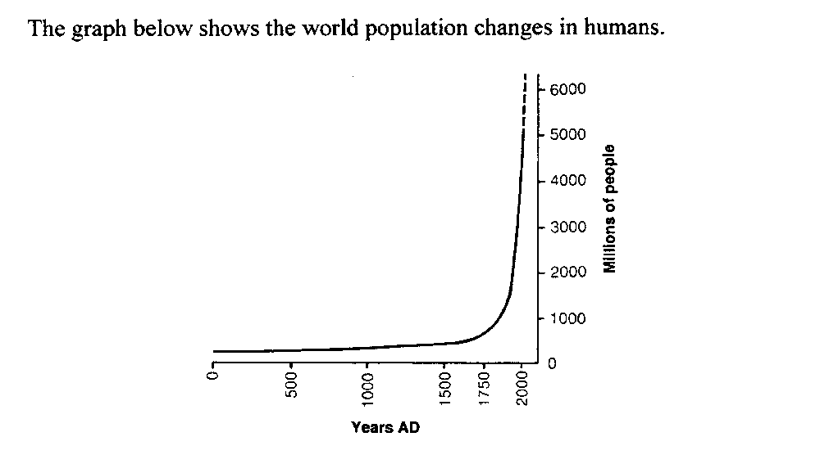

12. How many years did it take for the population of the world to double from 500 million to 1 000 million?

(a) 500 years (b) 550 years
(c) 50 years (d) 5000 years

13. Which of the following best defines in a biological sense the term community?

(a) the number of organisms of a species in an area at a particular time
(b) all the living organisms in an area at a particular time
(c) how organisms interact with each other and their environment
(d) all living organisms and the non living surroundings in an area

14. An ecologist takes 10 samples in a 150 square metre area of a particular plant species. The samples are taken using a 1 metre square quadrant. The results are shown below

Sample | 1 | 2 | 3 | 4 | 5 | 6 | 7 | 8 | 9 | 10
Number | 22 | 10 | 4 | 6 | 0 | 23 | 10 | 12 | 1 | 1

What is the average number of plants per quadrate square area?

(a) 8.9 (b) 9
(c) 8.8 (d) 9.1

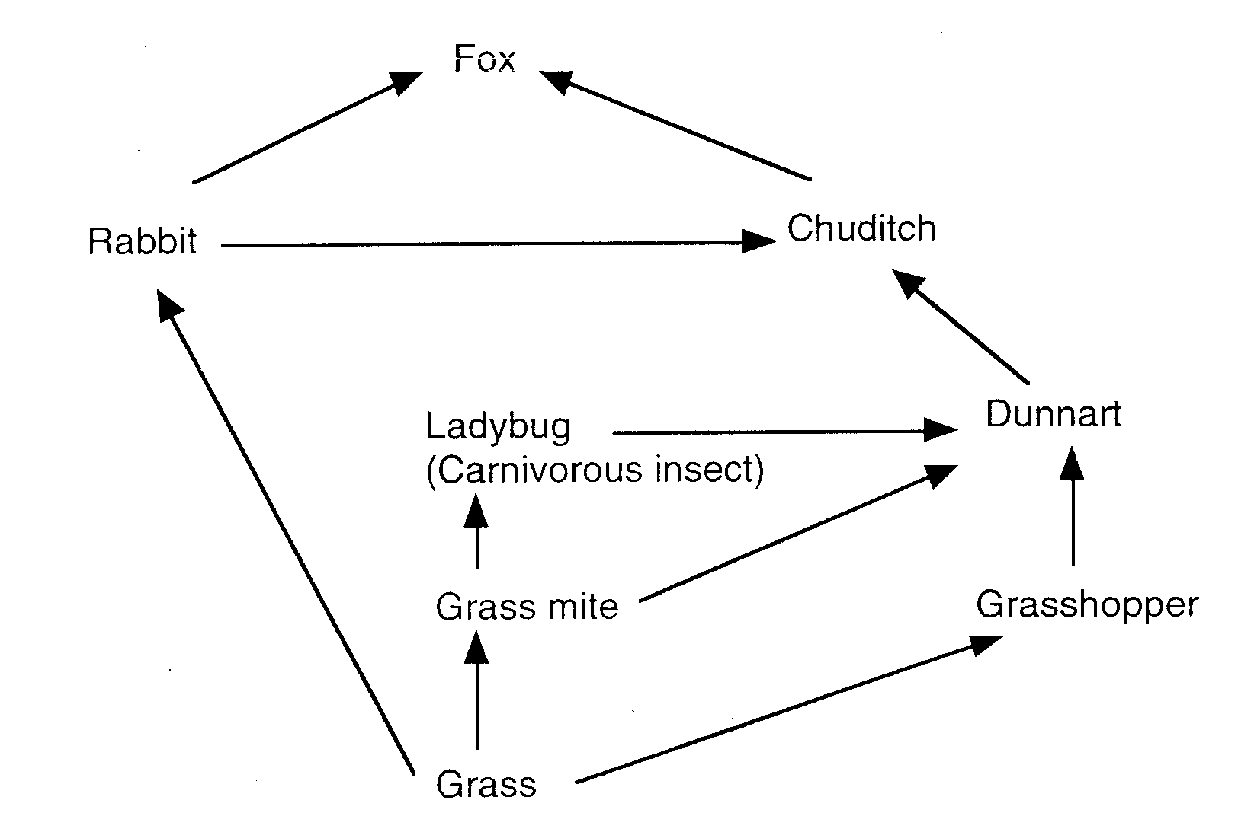
The next three questions are based on the following diagram.
The above diagram shows a simple food web found in the south west of Western Australia.

15. Which of the following would you expect to have the greatest biomass?

- Fox
- Grass
- Dunnart
- Rabbit

16. If the area was sprayed with DDT, in which organism would you expect to find the highest concentration?

- Fox
- Grass
- Dunnart
- Rabbit

17 If the DDT wiped out all the grass mites, which of the following would be the most likely short-term effect?

- A drop in the number of dunnarts.
- A rise in the number of grasshoppers.
- An increase in the biomass of grass.
- A rise in the chuditch population.

- Residual chemicals, such as the banned pesticide DDT, are concentrated in the body tissues of animals that eat it. The higher up the food chain, the higher their body tissue concentrations will be. This is called
  - sustainability.
  - biodiversity.
  - biomagnification.
  - natural selection.

- Which of the following is least likely to upset the natural balance of an ecosystem?
- Killing off or removing all of one species of plant or animal.
- Introducing a new pest insect.
- Climate change caused by carbon emissions and global warming.
- Seasonal changes in temperature and rainfall
Short Answer 41 marks
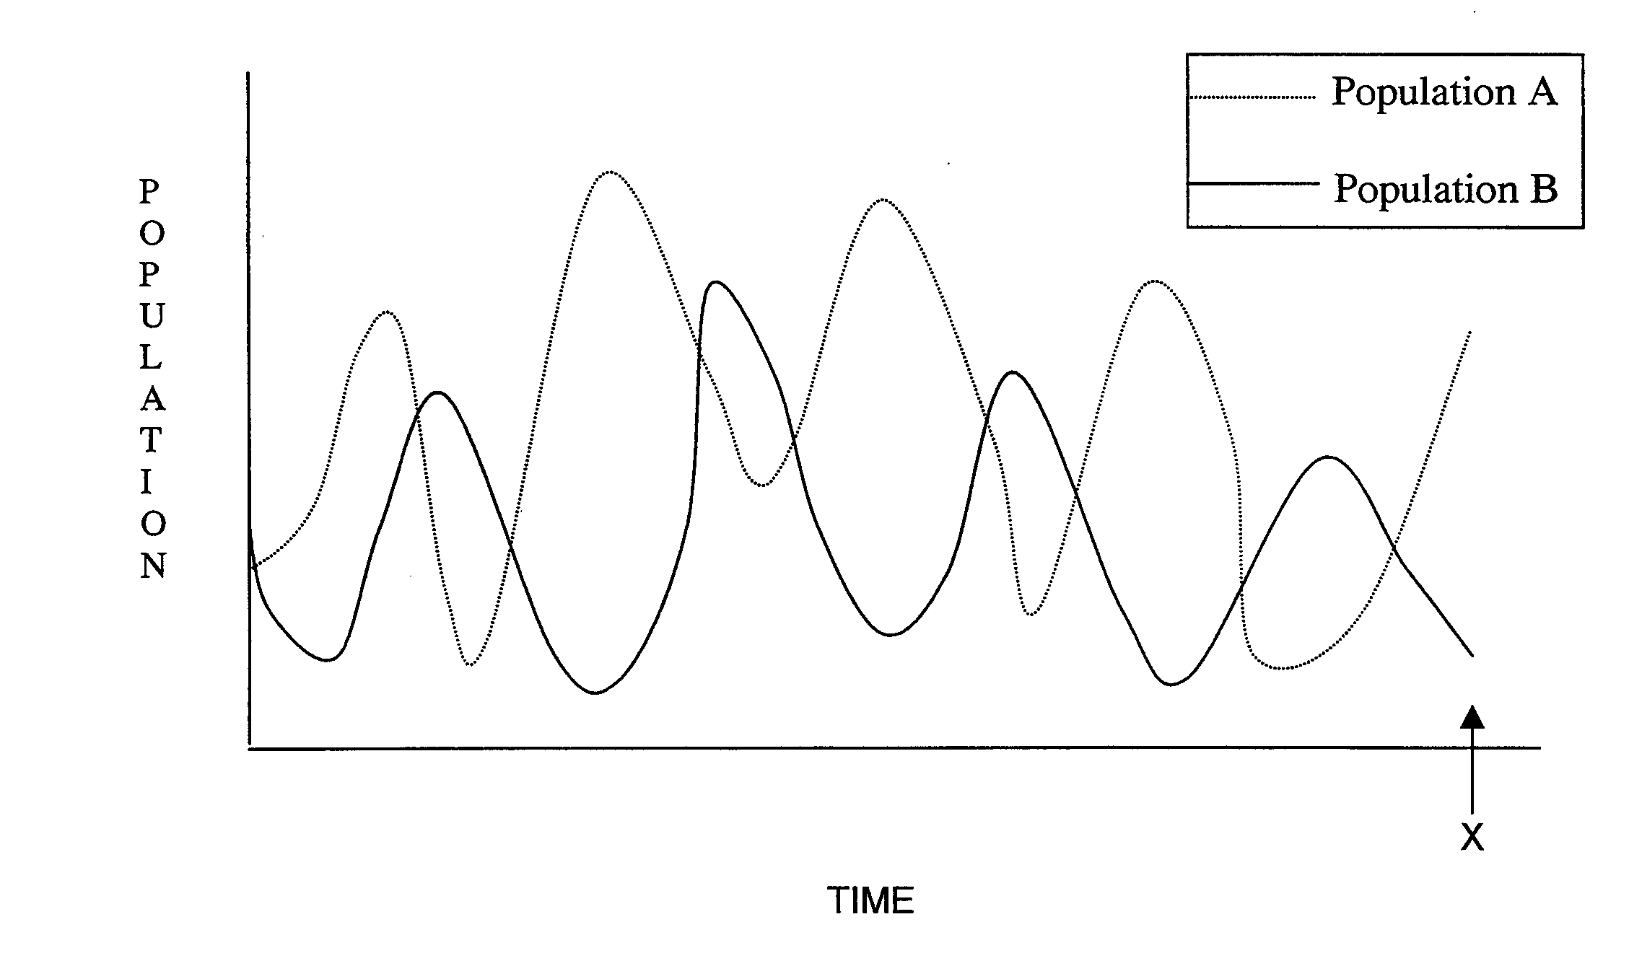
21. a. In a natural community there is interaction between populations of different species. This interaction can be shown in graphical form. Study the graph shown below, then answer the questions that follow.

i) Explain what is happening to the two populations (A and B) shown in the above graph. (1 mark)
________________________________________________________________________________________________________________________________________________________________________________________________________________________________________________________________________________________________________________________________

ii) Predict what is likely to happen to the two populations beyond time X.

(1 mark) ________________________________________________________________________________________________________________________________________________________________________________________________________________________________________________________________________________________________________________________________

The following table shows the number of mice caught in 10 traps randomly placed in a 100 hectare field over a period of 12 months.
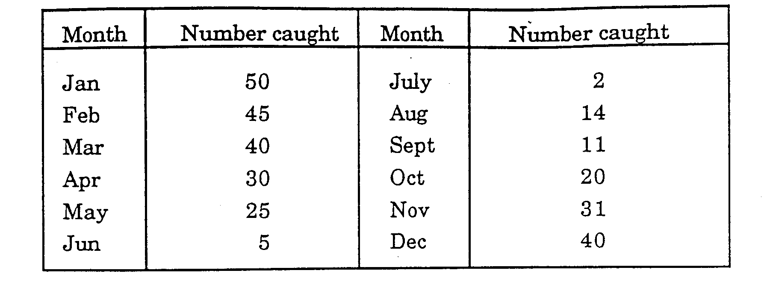
b. For the mice in this field, determine between which two successive
months there was the greatest rate of change in the population size.
Show your reasoning. (2 marks)
________________________________________________________________________________________________________________________________________________________________________________________________________________________________________________________________________________________________________________________________

c. Give any two assumptions we would have to make about the
sampling method in order to be confident in our answers to (a) and (b)
(2 marks)
________________________________________________________________________________________________________________________________________________________________________________________________________________________________________________________________________________________________________________________________

d. If the rate of population growth in these mice at a certain time was
200/1000/Year, the immigration rate was 40/1000/year, death rate
was 10/1000/year and birth rate was 180/1000/year, what would have
been the emigration rate? Show your working. (2 marks) ________________________________________________________________________________________________________________________________________________________________________________________________________________________________________________________________________________________________________________________________

Total 10 marks

22. A student set up a culture medium in a beaker and inoculated it with a solution containing unicellular green algae. She estimated that the solution contained 145 algal cells.
Over a period of 35 days she estimated the number of algal cells in her culture medium using a sampling method. Her results are shown below.

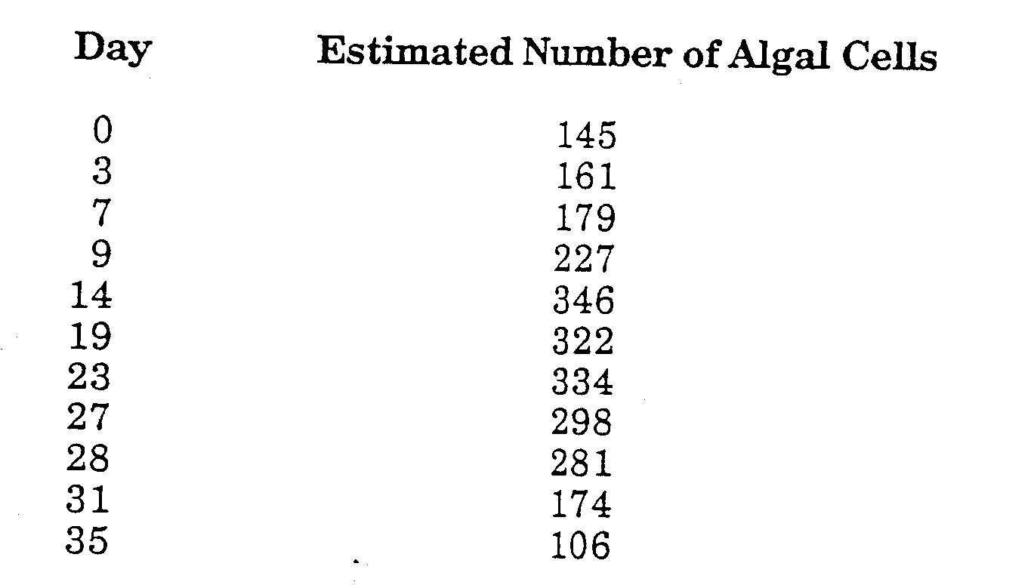
a. Draw a graph of the student's results on the grid on the following page.
(5)



b Between what two days was the rate of growth of the population greatest?

(1mark)
________________________________________________________________________________________________________________________________________________________________________________________________________________________________________________________________________________________________________________________________

c. Suggest why the population curve for the algae rose and then declined.
(2 marks)
________________________________________________________________________________________________________________________________________________________________________________________________________________________________________________________________________________________________________________________________

Total = 10 Marks

23. Which of the following factors are biotic and which are abiotic (write them under the appropriate column in the table below)
predators, parasite, temperature, light, water, competitors, prey, oxygen, humidity, pH, wind, soil type.

Biotic | Abiotic
(6 marks)

Refer to following diagram to answer question 24

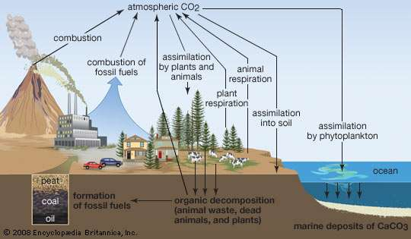
- Name the process that assimilates Carbon dioxide into plants.

___________________________________________ (1 mark)

- List 4 processes that add Carbon Dioxide to the air. (4 marks)

________________________________________________________________________________________________________________________________________________________________________________________________________________________________________________________________________________________________________________________________
- Define the term combustion. (1mark)

________________________________________________________________________________________________________________________________________________________________________________________________________________________________________________________________________________________________________________________________

- Describe how a carbon atom in coal could end up in a penguin. (4 marks)

________________________________________________________________________________________________________________________________________________________________________________________________________________________________________________________________________________________________________________________________

- Explain how human activity such as deforestation disrupts the natural carbon cycle. (4marks)

________________________________________________________________________________________________________________________________________________________________________________________________________________________________________________________________________________________________________________________________
Total 14 marks

25. Match the following terms with there correct definition by writing the corresponding letter after each definition.

A Commensalism An organism which lives in or on another._____

B Mutualism to work with another. ______

C Competition
The living together of two organisms of different species.
_________

D Parasitism close relationship between two organisms in which both benefit._______

E collaboration A relationship between two organisms whereboth strive to obtain the same resources.
________

close relationship between two species of organisms in which one benefits and the other is not disadvantaged.
________

(5 marks)

YEAR 11 ATAR BIOLOGY

Task 6: Ecosystems Dynamics
SCORES:
MC: /19

SA: /41

TOTAL: /60

_______ %

NAME:_____________________________

TEACHER:__________________________

DATE:______________________________

Section A: Multiple choice (19 Marks)
Answer all questions by circling the most correct answer on the multiple choice answer sheet.

1. a b c d 18. a b c d
2. a b c d 19. a b c d
3. a b c d 20. a b c d
4. a b c d
5. a b c d
6. a b c d
7. a b c d
8. a b c d
9. a b c d
10. a b c d
11. a b c d
12. a b c d
13. a b c d
14. a b c d
15. a b c d
16 a b c d
17 a b c d

Narrogin Senior High School

YR 11 Biological Science Test – Task 6

MULTIPLE CHOICE ANSWER SHEET

NAME:

Instructions

From the alternatives given in the question, choose the answer which is correct or best. Put a cross through the corresponding letter on the answer sheet below. If you make an error, circle your incorrect answer and mark the alternative you think is correct with a cross. Each question has only one correct answer.

1. A B C D 9. A B C D

2. A B C D 10. A B C D

3. A B C D 11. A B C D

4. A B C D 12. A B C D

5. A B C D 13. A B C D

6. A B C D 14. A B C D

7. A B C D 15. A B C D

8. A B C D 16. A B C D

